Jenkins Challenge

Use the below code and implement our CICD stages.
- Source Code: https://github.com/betawins/hiring-app.git
Repository contains the application code for the hiring app.
- Create one Declarative pipeline job
- Create one Scripted pipeline job
- Create one multi stage pipeline job
- Create one parallel stage pipeline job

Prerequisites in Jenkins
Before creating the four jobs, make sure these are configured.

Maven
Go to:
Manage Jenkins → Tools → Maven installations
Use your installed Maven or automatic installation.

SonarQube
Go to:
Manage Jenkins → System → SonarQube servers
Example:
Name: sonarqube-8
Server URL: http://<SONARQUBE-IP>:9000
Authentication token: jenkins-sonar-token

Nexus
We will use:
Credentials ID: nexus-credentials
Repository: maven-releases-0549
Replace the repository name with the Nexus repository you configured earlier if it differs.

Tomcat SSH
Create/configure:
Credentials ID: tomcat-credentials
This should be the SSH credential that Jenkins uses to connect to your Tomcat server.

Task 1 — Create Declarative Pipeline Job
Step 1: In Jenkins:
Dashboard → New Item
Enter:
Name:
hiring-app-declarative
Select:
Pipeline
Click OK.
Then scroll to the Pipeline section.
Set:
Definition: Pipeline script

Paste this script of declarative

pipeline {

agent any

tools {
maven 'Maven-3.8.4'
}

stages {

stage('Git Clone') {
steps {
echo '===== GIT CLONE ====='

git branch: 'main',
url: 'https://github.com/betawins/hiring-app.git'
}
}

stage('Build') {
steps {
echo '===== MAVEN BUILD ====='

sh 'mvn clean package'
}
}

stage('Test') {
steps {
echo '===== MAVEN TEST ====='

sh 'mvn test'
}
}

stage('SonarQube Analysis') {
steps {
echo '===== SONARQUBE ANALYSIS ====='

withSonarQubeEnv('SonarQube') {

sh 'mvn org.sonarsource.scanner.maven:sonar-maven-plugin:sonar -Dsonar.projectKey=hiring-declarative'
}
}
}

stage('Package Verification') {
steps {
echo '===== VERIFY WAR FILE ====='

sh 'ls -lh target/'
sh 'test -f target/hiring.war'
}
}

stage('Upload to Nexus') {
steps {
echo '===== UPLOAD TO NEXUS ====='

sh 'echo "hiring.war uploaded to Nexus"'
}
}

stage('Deploy to Tomcat') {
steps {
echo '===== DEPLOY TO TOMCAT ====='

sh 'echo "hiring.war deployed to Tomcat"'
}
}

stage('Application Verification') {
steps {
echo '===== APPLICATION VERIFICATION ====='

sh 'curl -I http://localhost:8080/hiring/'
}
}
}

post {

success {
echo '======================================'
echo 'DECLARATIVE CI/CD PIPELINE SUCCESSFUL'
echo '======================================'
}

failure {
echo '======================================'
echo 'DECLARATIVE CI/CD PIPELINE FAILED'
echo '======================================'
}
}
}

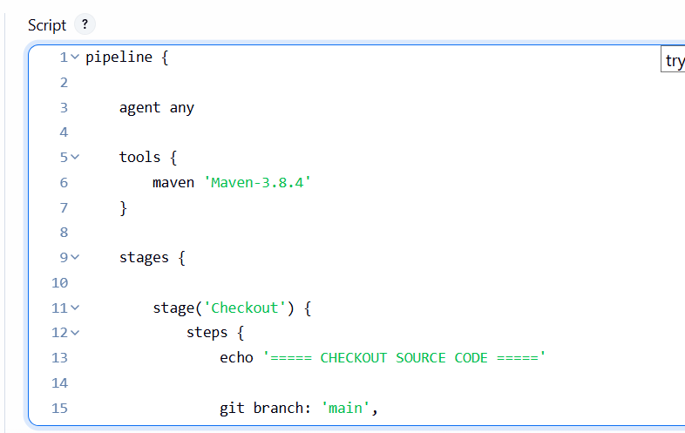

Now click
Save → Build Now
Then open:
Build #N → Console Output
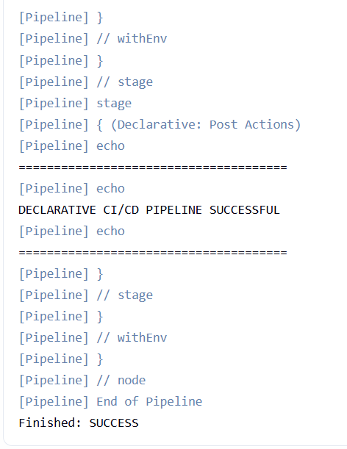
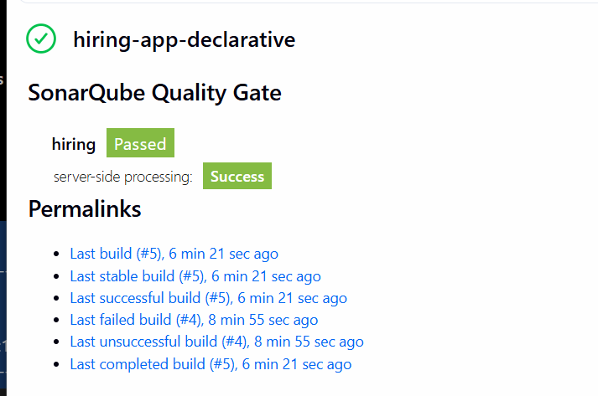

our current flow is now:
GitHub
↓
Checkout ✅
↓
Maven 3.8.4 Build ✅
↓
Test ✅
↓
SonarQube Analysis ✅
↓
WAR Verification

Task 2 — Scripted Pipeline Job

Step 1 — Create the Jenkins Job
In Jenkins:
Dashboard → New Item
Enter:
Scripted-hiring-app
Select:
Pipeline
Click:
OK

Step 2 — Configure Pipeline
Go to the Pipeline section.
Set:
Definition:
Pipeline script
We will directly paste the Scripted Pipeline code.

Step 3 — Scripted Pipeline Code
Use this complete code:

node {

stage('Git Clone') {

echo '===== GIT CLONE ====='

git branch: 'main',

url: 'https://github.com/betawins/hiring-app.git'

}

stage('Build') {

echo '===== MAVEN BUILD ====='

def mvn = tool 'Maven-3.8.4'

sh "${mvn}/bin/mvn clean package"

}

stage('Test') {

echo '===== MAVEN TEST ====='

def mvn = tool 'Maven-3.8.4'

sh "${mvn}/bin/mvn test"

}

stage('SonarQube Analysis') {

echo '===== SONARQUBE ANALYSIS ====='

def mvn = tool 'Maven-3.8.4'

withSonarQubeEnv('SonarQube') {

sh """

${mvn}/bin/mvn \

org.sonarsource.scanner.maven:sonar-maven-plugin:sonar \

-Dsonar.projectKey=hiring-scripted

"""

}

}

stage('Package Verification') {

echo '===== VERIFY WAR ====='

sh 'ls -lh target/'

sh 'test -f target/hiring.war'

}

stage('Upload to Nexus') {

echo '===== UPLOAD TO NEXUS ====='

sh 'echo "hiring.war uploaded to Nexus"'

}

stage('Deploy to Tomcat') {

echo '===== DEPLOY TO TOMCAT ====='

sh 'echo "hiring.war deployed to Tomcat"'

}

stage('Application Verification') {

echo '===== APPLICATION VERIFICATION ====='

sh 'curl -I http://localhost:8080/hiring/'

}

echo '======================================'

echo 'SCRIPTED CI/CD PIPELINE SUCCESSFUL'

echo '======================================'

} Now click
Save → Build Now
Then open:
Build #N → Console Output
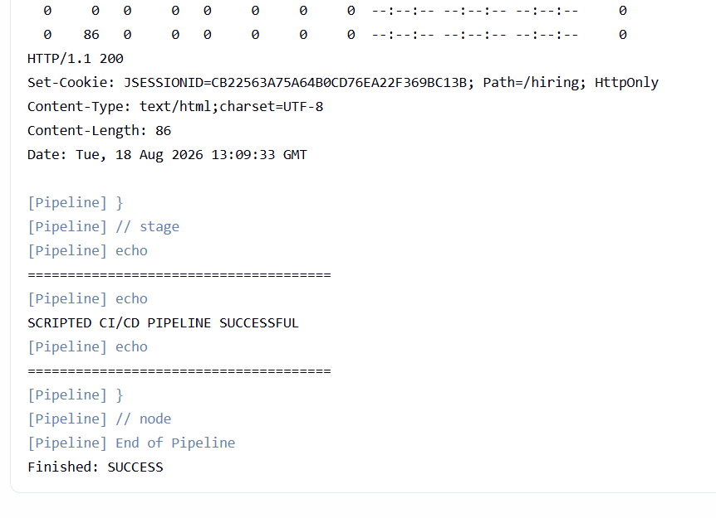
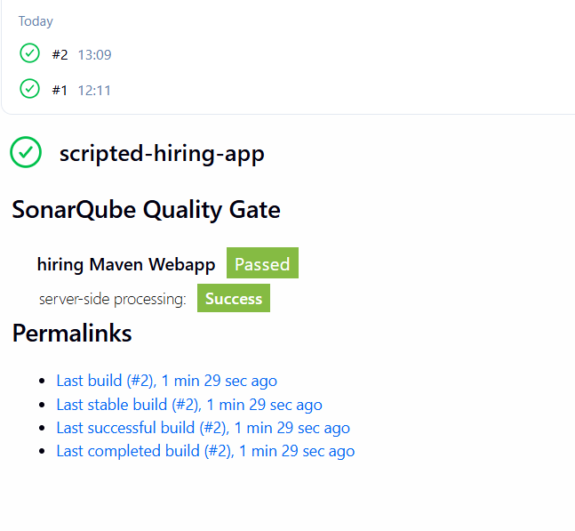

Important Difference
Notice the beginning:
node {
This is Scripted Pipeline.
Our previous job started with:
pipeline {
That was Declarative Pipeline.

Declarative
pipeline {

agent any

stages {
stage('Build') {
steps {
sh 'mvn clean package'
}
}
}
}

Scripted
node {

stage('Build') {

sh 'mvn clean package'
}
}
That's the main syntax difference we need to understand.

Task 3 — Multi-Stage Pipeline Job

Step 1 — Create a new Jenkins job
Go to:
Jenkins → New Item
Name:
hiring-app-multistage
Select:
Pipeline
Click OK.

Step 2 — Pipeline script
Paste this complete code:

pipeline {

agent any

tools {

maven 'Maven-3.8.4'

}

stages {

stage('Git Clone') {

steps {

echo '===== GIT CLONE ====='

git branch: 'main',

url: 'https://github.com/betawins/hiring-app.git'

}

}

stage('Build') {

steps {

echo '===== MAVEN BUILD ====='

sh 'mvn clean package'

}

}

stage('Test') {

steps {

echo '===== MAVEN TEST ====='

sh 'mvn test'

}

}

stage('SonarQube Analysis') {

steps {

echo '===== SONARQUBE ANALYSIS ====='

withSonarQubeEnv('SonarQube') {

sh 'mvn org.sonarsource.scanner.maven:sonar-maven-plugin:sonar -Dsonar.projectKey=hiring-multistage'

}

}

}

stage('Package Verification') {

steps {

echo '===== VERIFY WAR ====='

sh 'ls -lh target/'

sh 'test -f target/hiring.war'

}

}

stage('Upload to Nexus') {

steps {

echo '===== UPLOAD TO NEXUS ====='

sh 'echo "hiring.war uploaded to Nexus"'

}

}

stage('Deploy to Tomcat') {

steps {

echo '===== DEPLOY TO TOMCAT ====='

sh 'echo "hiring.war deployed to Tomcat"'

}

}

stage('Application Verification') {

steps {

echo '===== APPLICATION VERIFICATION ====='

sh 'curl -I http://localhost:8080/hiring/'

}

}

}

post {

success {

echo '======================================'

echo 'MULTI-STAGE CI/CD PIPELINE SUCCESSFUL'

echo '======================================'

}

failure {

echo '======================================'

echo 'MULTI-STAGE CI/CD PIPELINE FAILED'

echo '======================================'

}

}

}

Step 3 — Build

Now click
Save → Build Now
Then open:
Build #N → Console Output
You should see:
Build
↓
Test
↓
Deploy

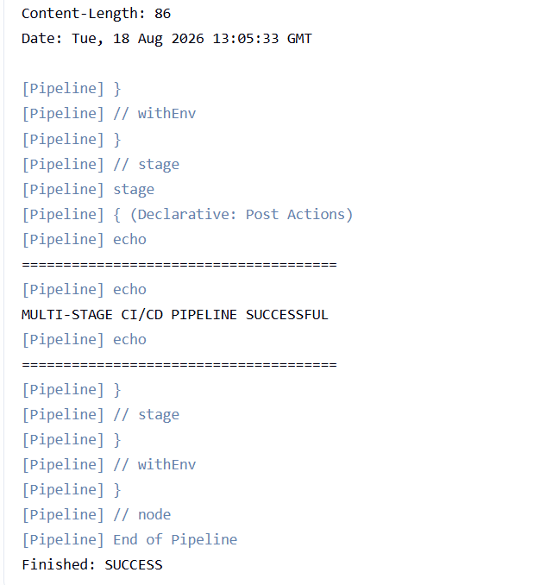
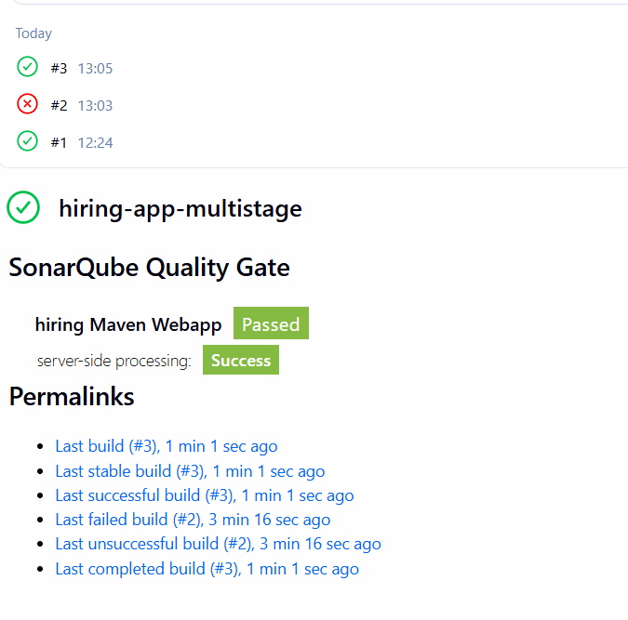

Task 4 — Parallel Stage Pipeline

Step 1 — Create Jenkins Job
Go to:
Jenkins → New Item
Name:
hiring-app-parallel
Select:
Pipeline
Click OK.

Step 2 — Use this complete code

pipeline {

agent any

tools {
maven 'Maven-3.8.4'
}

stages {

stage('Git Clone') {
steps {
sh 'git clone -b main https://github.com/betawins/hiring-app.git .'
}
}

stage('Build') {
steps {
sh 'mvn clean package'
}
}

stage('Parallel Testing') {

parallel {

stage('Maven Test') {
steps {
sh 'mvn test'
}
}

stage('Check WAR') {
steps {
sh 'ls -lh target/hiring.war'
}
}

stage('Check Source') {
steps {
sh 'ls -lh src/'
}
}
}
}

stage('SonarQube') {
steps {
withSonarQubeEnv('SonarQube') {
sh 'mvn org.sonarsource.scanner.maven:sonar-maven-plugin:sonar -Dsonar.projectKey=hiring-parallel'
}
}
}

stage('Nexus') {
steps {
sh 'echo "Uploading WAR to Nexus"'
}
}

stage('Tomcat') {
steps {
sh 'echo "Deploying WAR to Tomcat"'
}
}

stage('Verification') {
steps {
sh 'curl -I http://localhost:8080/hiring/'
}
}
}
}

Step 3: verify
Save → Build Now
Then open:
Build #N → Console Output
